**Tab 2- Accommodation**

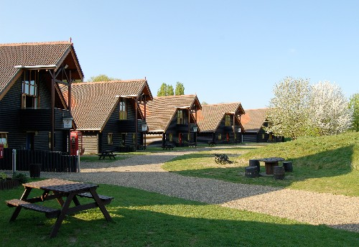 location map here (not necessarily interactive)

The accommodation at Lee Valley is ideally situated just 20 minutes from London’s central Liverpool street station. It’s in the countryside surrounded by 10,000 acres of nature parks, leisure activities, rivers and heritage sites. A safe and beautiful area for your children to enjoy their time in the UK learning English, making new friends and having fun all at the same time.

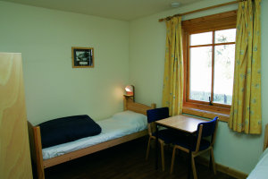 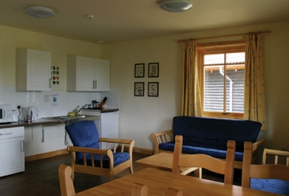 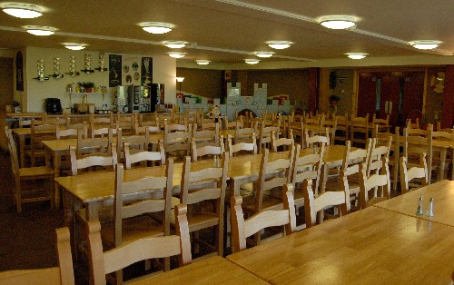

The luxuriously spacious and comfortable log cabins, where the children will sleep during this residential course, are fully equipped and have a relaxing common room area to talk to and enjoy spending time with the friends they will make during the camp.

**Facilities on-site: (list here)**

Classrooms, Common Room, Library, Lounge, TV Lounge, Garden, Cycling, Shop, Meals, Cafe, Dining Room, Restaurant, Laundry, WiFi Internet access, Washing machine